6th Grade Science Assessment S6E1b.

Which diagram below accurately represents the relationship between the earth, universe, and galaxy?

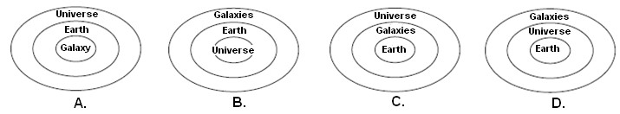

Where is our solar system located in the Milky Way Galaxy?

1. center
2. outer rim (arm)
3. outside the galaxy
4. not part of the Milky Way Galaxy

Why can’t the shape of the Milky Way Galaxy be seen from the Earth?

Draw a diagram representing the Milky Way Galaxy. Next, mark and label where our solar system would be located in the Milky Way Galaxy.